Team DECOHERENCE Authors (Reverse Alphabetical):

Zirui Zhan, Venkata Vikhyat Choppa, Yogesh Patil, Ethan Hu, Keith Cannon

Table of Contents

**Goal 1**

**Methodology 2**

**Observations 4**

**Limitations and potential improvements 8**

**Error Migration 9**

**Conclusion 9**

**Sources 9**

## Goal

Many-body quantum scars represent a novel phenomenon originally identified by quantum computing techniques. Informally, we witness a loss of information in the initialised quantum state more slowly than we would expect; there appears to be a privileged subset (and is not definitively known if it is true for other subsets) of the Hilbert space of the quantum system that tends to be revisited over the course of its time evolution. More specifically, if we start a 2^N quantum system in an anti-ferromagnetic (AF) or anti-parallel initialization, such that each alternating qubit is up or down, we witness a revisitation to this state rather than the expected thermalization of the system.

The physical realisation of this 2-level, N qubit system in our case is that of the QuEra Quantum Processor Aquila. It is a 2-D layout of Rb atoms in the 2 state basis of either their ground state and excited Rydberg state. An image of an atomic-light interaction with detuning is shown below.

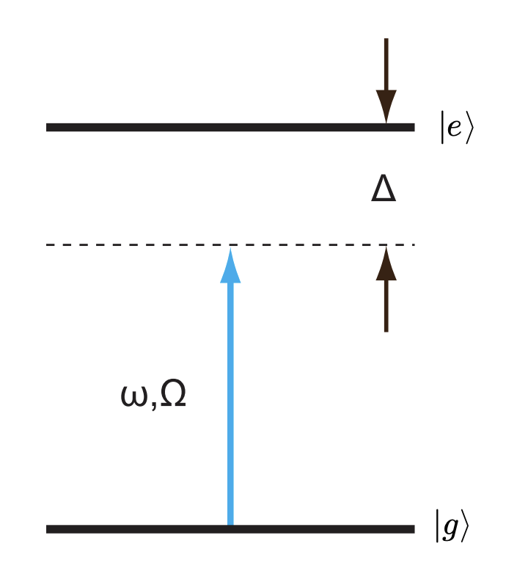

(Figure [source](http://info.phys.unm.edu/~ideutsch/Classes/Phys566F13/Notes%20from%20others/Atom-Light%20Interactions.pdf))

The relevant Hamiltonian for this system, with N atoms, Omega driving frequency, delta (commonly also Delta) detuning, and a strong but rapidly decaying (d^-6) Van der Waals interaction between atoms .

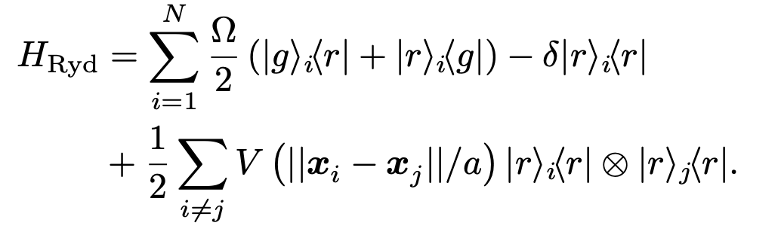

Crucially, we will be taking advantage of the fact that VdW interaction prohibits neighboring atoms from being in the excited state (enforcing adjacent states to be bit flipped). The image below conveys the approximate idea, with labeled detuning and radius parameters:

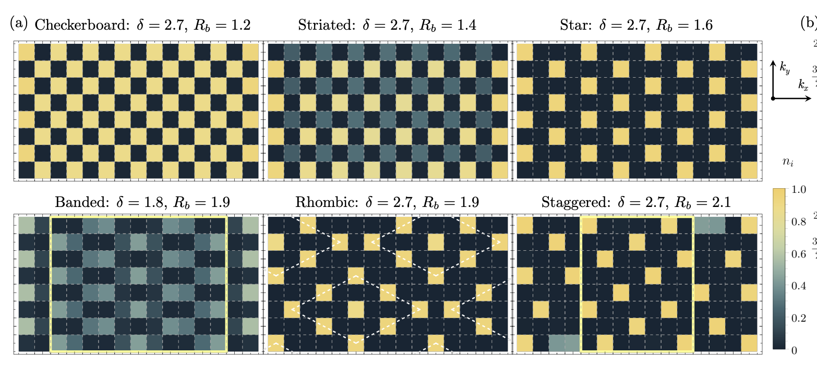

(Figure [source](https://arxiv.org/pdf/1910.09548.pdf) Samadjar et al.)

Our goal is to exhibit the quantum scar phenomenon and witness the revival of an ordered state (e.g. Z2) after initialization and quenching. In particular, we aim to maximize the probability of returning to an ordered state after the quench, i.e. the probability of the first observable quantum scar.

## Methodology

An outline of our approach is as follows:

1. Optimise the Rabi frequencies waveform and Detuning waveform (for state preparation) for the 1D Chain model
2. Confer the literature on possible atom geometries. For realisable Rydberg blockade radii and driving fields, reason analytically for restrictions on possible geometries
3. Iterate through possible geometry alternatives to increase the packing density of atoms.
4. Submit candidate programs to QPU via the cloud (next time ;))

Our degrees of freedom were the geometry (including atom count) of the physical graph, the Rabi frequencies (Omega), and the detuning field (Delta) in the Hamiltonian. Because of the performance of simulating even classic Hamiltonians under different parameters, usually lasting 2-20 minutes for approximately 6-12 atoms on local C/GPUs, brute force simulation was not feasible.

In order to iterate through possible optimized parameters, we first prioritized our work to focus on increasing the packing density of atoms in our geometry by extending it from the linear (Chain) as described by the blockade scar tutorial.

Geometry Considerations

We found a prioritization of geometries based on packing density. Circle packing as a mathematical problem has been studied, and based on observations from that literature, we reasoned honeycomb arrays would likely pack atoms most densely. We also drew insight from experimental observations as shown:

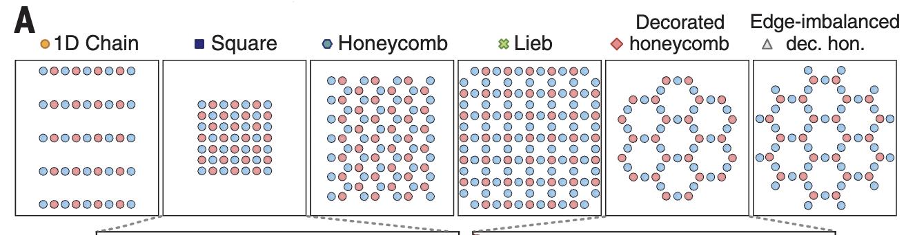

(Figure [source](https://www.science.org/doi/epdf/10.1126/science.abg2530) Bluvstein et al.)

Drive amplitude and detuning parameter optimization of the adiabatic initialization ramps

In order to ensure initialization into an AF state before the quench, the adiabatic ramp of the Rabi frequency and detuning was optimised. We did this optimization by measuring the fidelity of the initialization into an ordered state (e.g. the AF state).

Moreover, we also simply optimised the probabilities for observing the quantum scars though experimentation and comparing with benchmark values for various geometries.

The maxima and the minima have been calculated based on the Rb values being calculated based on the delta and omega values and the rydberg blockade between the qubits.

The maximal optimal probabilities have been reached by using the wave pattern, with optimal wavelength, by piecewise linearity change for the rydberg detuning to optimal values of [-18.8, -18.8, 19, 19] using the following probability distribution of the qubits as follows: the z2 state.

Further optimization of the ramp has been achieved by using the sigmoid functions for smoothing the rydberg curve to achieve the expected state and excitation. Fine tuning the rabi frequency values for the optimal probability.

Implemented nearest neighbours to find out the next occurrence in the pattern satisfying the sequence and avoiding rydberg blockade cognition between the qubits.

There were some mild optimizations achieved using the distance and the angles values with mid range of -18.4, -18.4, 19, 19. To achieve maximum qubit density curve based geometry like ellipsis has also been used that can be scaled to n to include applicable geometry for the excitation and have maximum qubit density.

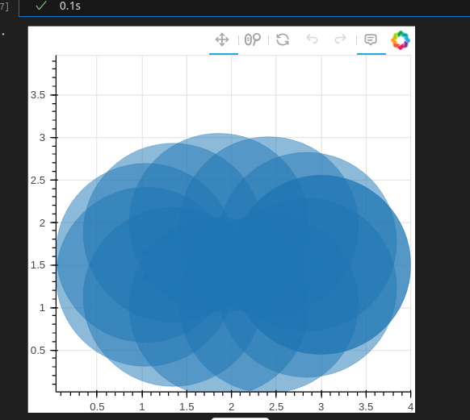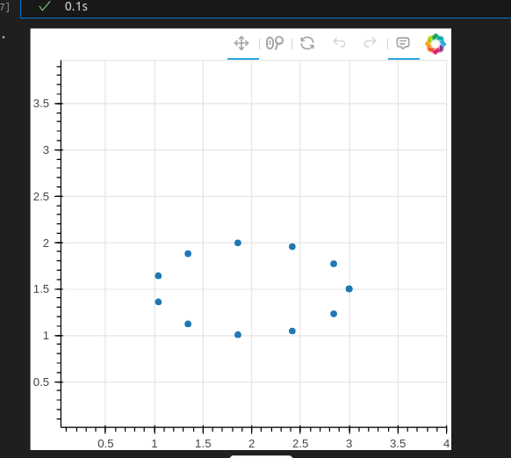

Ellipse Geometry structure

## Observations

| Geometry | **Atom Count (/unit cell)** | **Area/atom [um2]** | **Rabi frequency** | **Detuning** | **Quantum Scar Probability** |
| --- | --- | --- | --- | --- | --- |
| Decorated Honeycomb | 12 | 214 | 15.7 | 19 | 0.55 |
| 2D array of decoupled chains | 15 | 76 | 15.7 | 16.3 | 0.4 |
| “Parallelogram” | 12 | 71 | 15.7 | 24.7 | 0.34 |
| “Triangular, Square,Leibnitz, Kagome,Ellipse” |  |  | 15.7 | 16.3 | < 0.2 |

For Triangular, Square, Leibitz, and Kagome shapes, we were unable to find significant quantum scaring probability with the setup that we have, where in the case of square, triangular, the Z2 state is hard to prepare prior to quenching.

According to Bluvstein et al., the decorated honeycomb shows a significant probability of quantum scarring and we were able to reproduce their result in some magnitude through Monte Carlo linear sweep across the upper and lower bound of the delta used for the initialization before the quench.

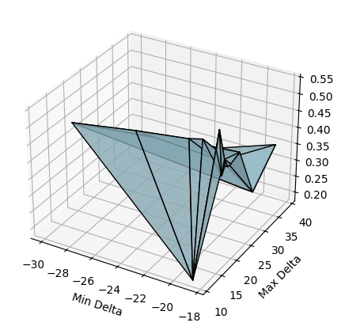

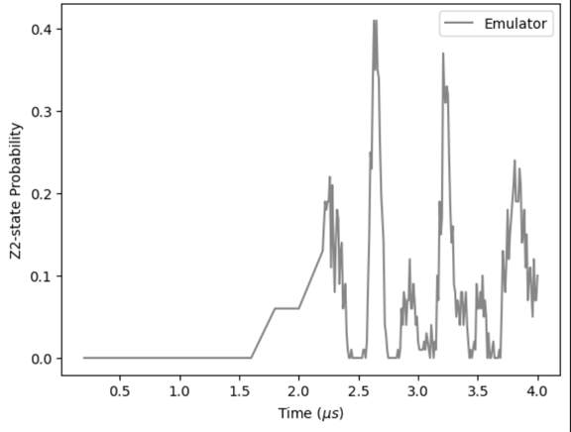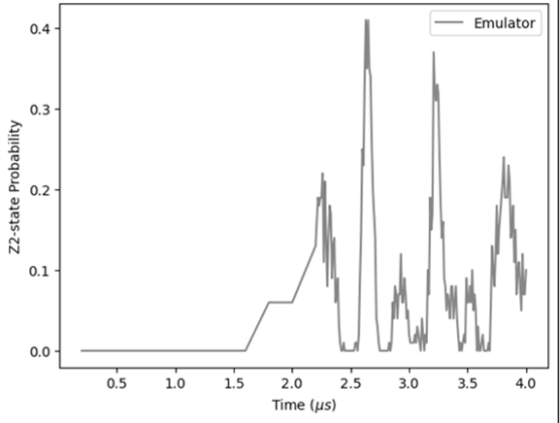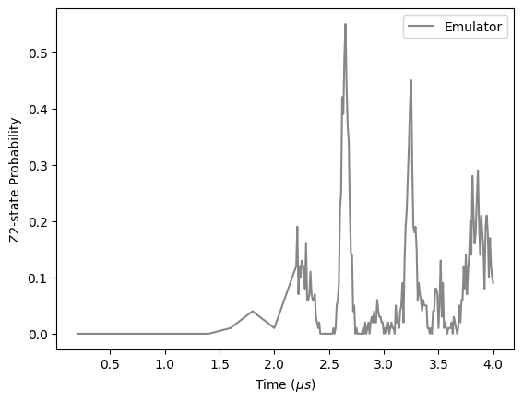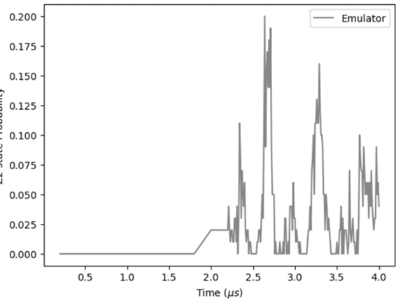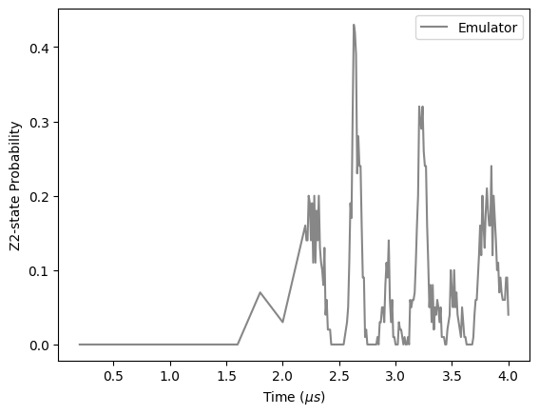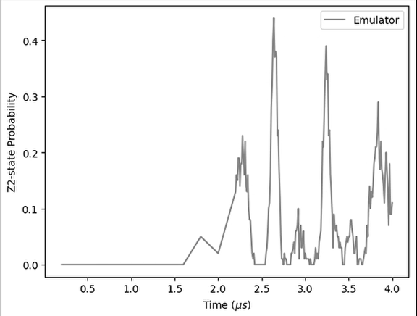

In the graphs, the the detuning is ‘swept’ from a constant minimum of -18.8 to varying

maxima values of 11,19, 20, 21, 22, 23, corresponding to left-right, top-bottom above

From the tutorial, we saw that a 1D chain with an odd amount of atoms shows a high probability of quantum scarring (~80%). Thus, to increase the number of total atoms, we decided to stack multiple chains parallel to each other, sufficiently outside the blockade radius. The stacking of multiple chains reduces the overall probability of the system as expected as the overall geometry approaches rectangular shape, which we have found to produce low levels of quantum scarring.

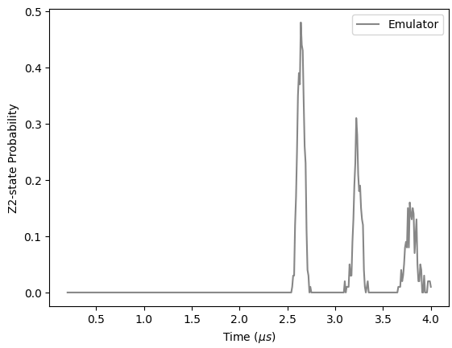

2 chains of 7 atoms (a=6.1) parallel to each other with 18.3um apart

We have also discovered a shape that offers very interesting properties. The “Parallelogram” is inspired by the effort to maximise the packing density in 2D, which is the triangular lattices, but with a twist. Since we know that equilateral triangular lattices have trouble generating Z2 states, we decided to use 30-60-90 triangles to create a shape where the shortest distance (opposite of the 30-degree angle) will be less than the blockade radius, the second and the third shortest distance will be greater than the blockade radius.

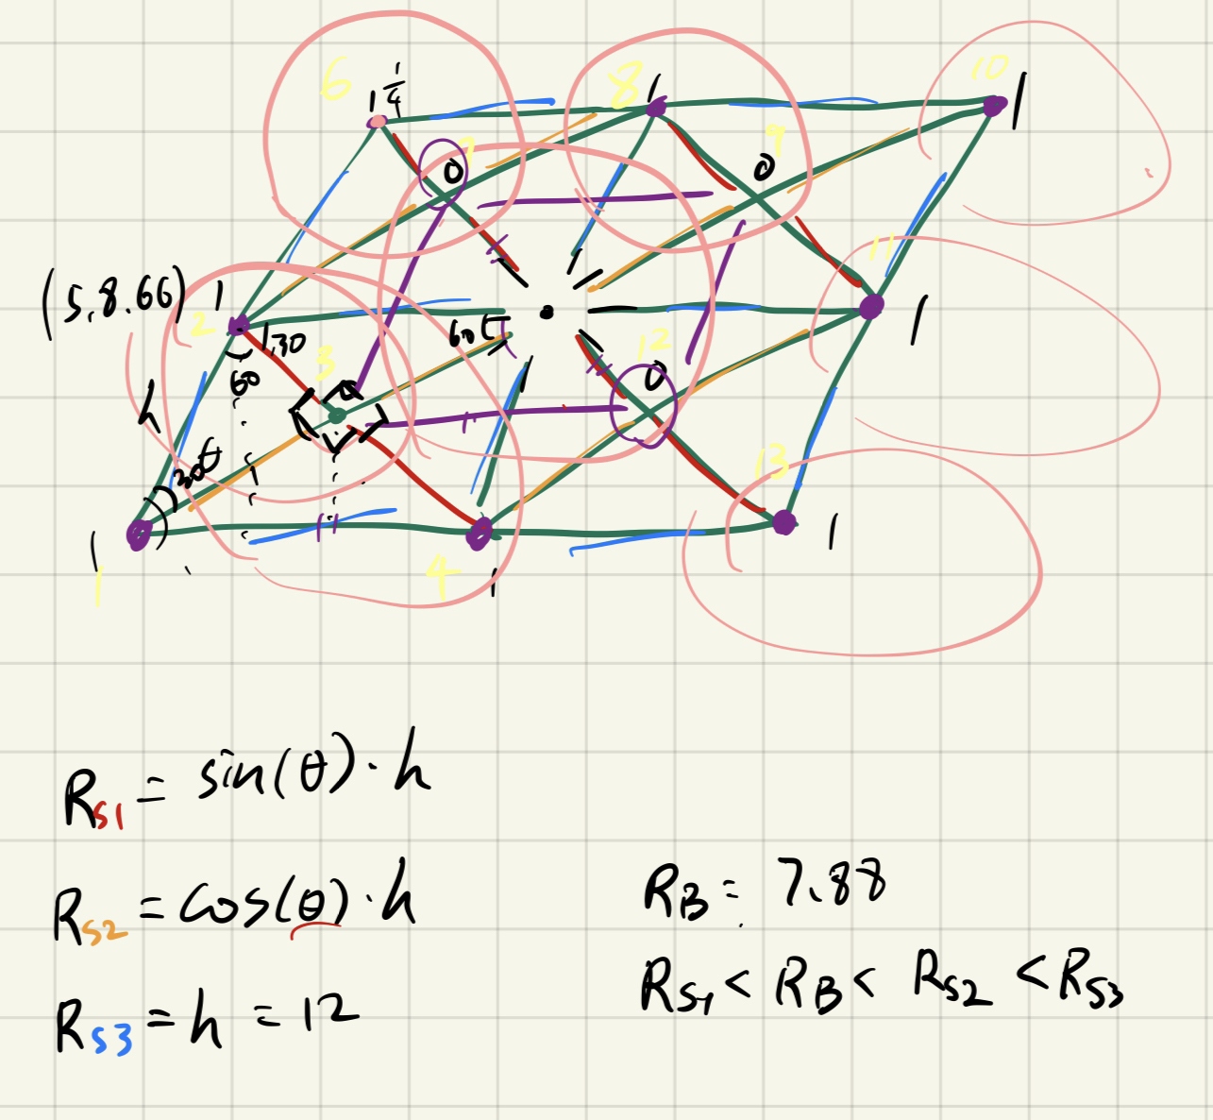

Original sketch for the Parallelogram

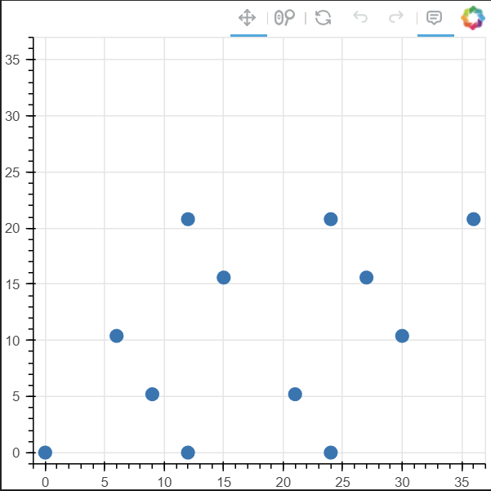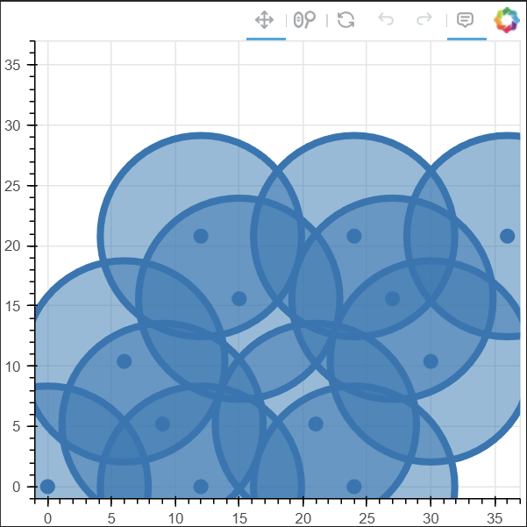

Coordinate graph for the Parallelogram, Rb is toggled on right.

We attempted to simulate a 13-atom system of this, but the result shows a quantum scarring probability of less than 10%. However, when we removed the atom at the very center, we were able to get the quantum scarring probability up to nearly 35% for the first quantum scar peak. However, we observed that the recurring peaks are much smaller than any other geometry we have tried, which we are unsure of why, and its connection to quantum scarring. We also did a rough sampling across the possible delta to find an optimal delta max value for this geometry.

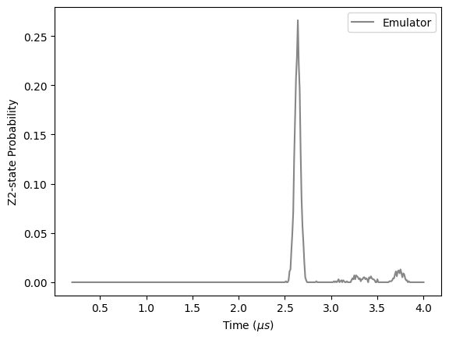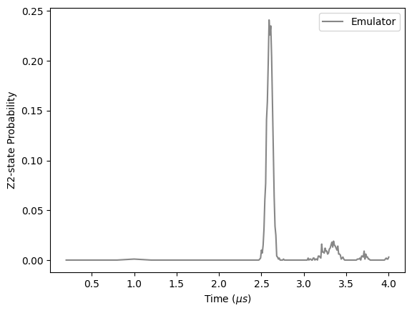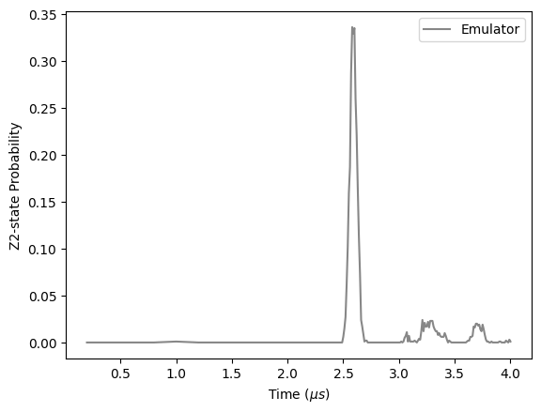

Sweeping through Delta max from 10 to 30, maximum at around 24

Additionally, we have tried to reduce the angle from 30 to 22.5 degrees, but the results are less appealing with or without the central atom.

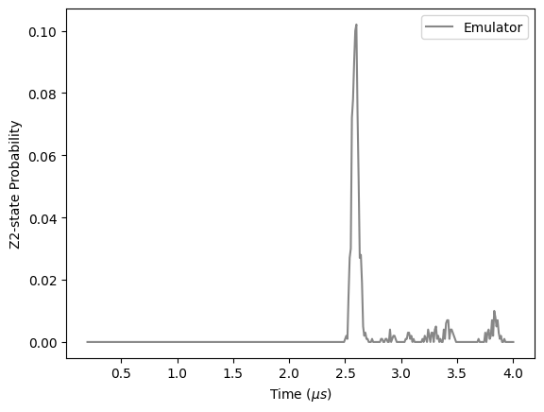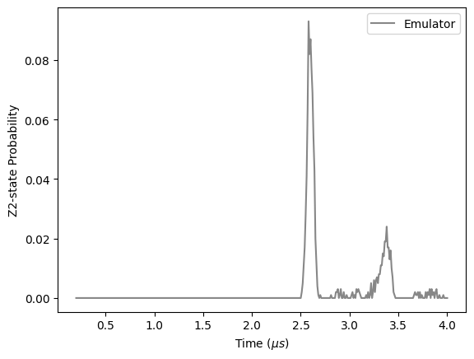

22.5 degree Parallelogram with central atom (left), without central atom (right)

## Limitations and Potential Improvements

We note a few curiosities. In a few rare instances, we noticed that the provided Blockade object classes (for python) had poorly controlled behaviour and performance, e.g. “rectangular”. We found success by defining a custom arrangement (specifying the locations) of atoms.

In our realization of this challenge, we optimized the quantum scarring probabilities without optimizing for the coherence time of the post-quench system, though driving the system post-quench has been seen to protect the coherence (improve lifetimes) and improve the quantum scar probabilities (cf. [D. BLUVSTEIN](https://www.science.org/doi/full/10.1126/science.abg2530#con1) et al.) This could be a potential improvement to the schemes suggested and attempted here.

## Error Migration

Note: Due to the quantum hardware constraints, error was simulated with the parameters 0.05 and 0.01. Readout error mitigation (REM) was performed using the inverse confusion matrix, generated with the size of the bitstring, combined with the given probability parameters. A sample was taken from the quantum scar example at time 2.63, which was used as the sample probability distribution to generate the sample error distribution. With the inverse confusion matrix multiplied with the sample error distribution, the readout showed the reversal of errors introduced artificially.

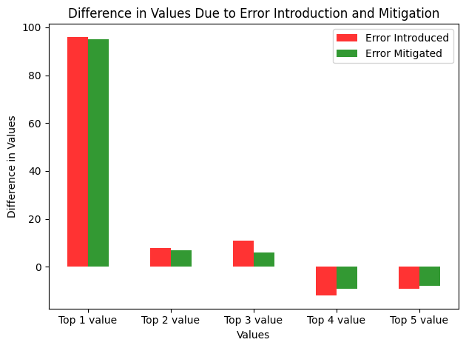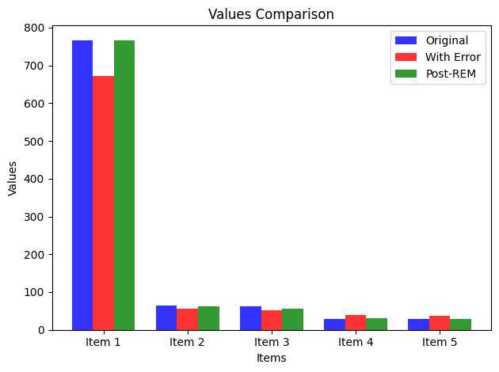

## Conclusion

We aimed to optimize the Rydberg Hamiltonian for the highest probability of exhibiting at least one quantum scar. In terms of atom geometry, the honeycomb optimises for the highest probability (peak amplitude) for the quantum scar, as suggested by the existing literature. We tried a parallelogram, which optimizes the packing density. Repeated linear chains offer a comparable probability of quantum scarring effect to the honeycomb; however, with inferior packing density, the probability of quantum scarring decreases as one attempts to increase the packing density of the repeat linear chains. Observations and suggestions are also provided.

## Sources

1. Excited state diagram: <http://info.phys.unm.edu/~ideutsch/Classes/Phys566F13/Notes%20from%20others/Atom-Light%20Interactions.pdf>
2. Phase diagram <https://arxiv.org/pdf/1910.09548.pdf> and checkerboard image
3. Recommeded reading on challenge